Statistics Lecture 8.2: An Introduction to Hypothesis Testing

Hypothesis Testing:
Testing whether or not a claim is valid.

Examples:
“Most people get their jobs through networking.”
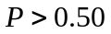

“The average payload of trucks on the 99 freeway is 18,000 lbs
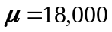

Rare event rule:
If the probability of an assumption occurring is “very small” then the assumption is probably is incorrect.

Example
Gender selection:
Claim: At least 80% chance of having a girl.
100 couples were studied.
The assumption: The drug does not work.
50% girls and 50% boys

1) 52 out of 100 couples had girls.
2) 97 out of 100 couples had girls.
Parts of a Hypothesis test.
- Null Hypothesis vs Alternative Hypothesis.
Null hypothesis: 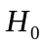
- States that the population parameter (Mean , Proportion ) is equal to some value.
Example
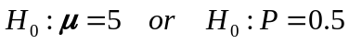

NOTE: How to test a hypothesis
Start by assuming the is true.
Then, use evidence to reach a conclusion.
* Reject the Null hypothesis
I have enough evidence to prove wrong

* Fail to Reject the Null hypothesis
I do NOT have enough evidence to prove wrong

You cannot accept the Hypothesis.

- Alternative Hypothesis. 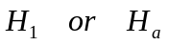
Alternative hypothesis: 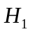
- States that the parameter (Mean , Proportion ) has a value different than :
There are three ways to be different than 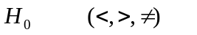
Examples:
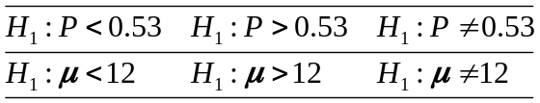

* if you want to support a claim, then you must stated it as a () Alternative hypothesis.
Not ()

Example
Gender selection:
Claim: At least 80% chance of having a girl.

Suppose you want to prove that your fertility drug works.
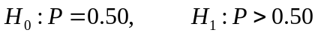
How to identify 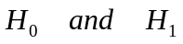
State the original claim symbolically.
State the opposite of the origin claim as well.

NOTE: the original claim could be or
Depends on where the equality is

Example
- The mean of fluid is at least 12 ounces in a can.
Claim: 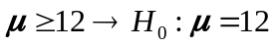 wherever the equals sign is where the is.
Opposite: 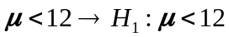

- The Proportion of male CEO is greater than .5 (most CEO’s are male)
Claim: 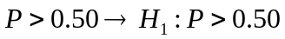
Opposite: 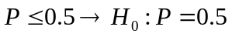

- The Mean weight babies is at most 8.9 lbs
Claim: 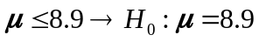
Opposite: 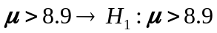

- The Mean IQ score is 100
Claim: 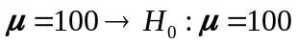
Opposite: 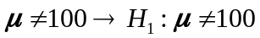

Test Statistic:
Proportion: 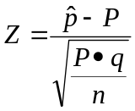

Mean: 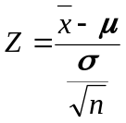 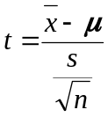

Example:
Survey:
A sample of 706 companies found that 61% of CEOs were male.
Claim: most CEO’s are male

1) Claim: 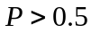 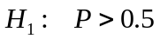
Opposite: 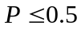 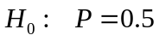

- Test Statistic:
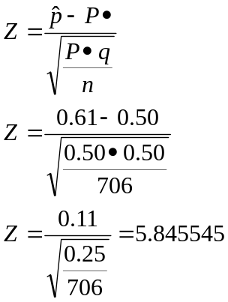

How to make a decision?
Significance level.
Common Significance levels.
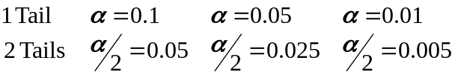

Critical Values:
Separates rejection region from the fail to reject region
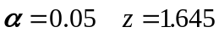

Rejection region:
If our test statistic falls into this region then reject .

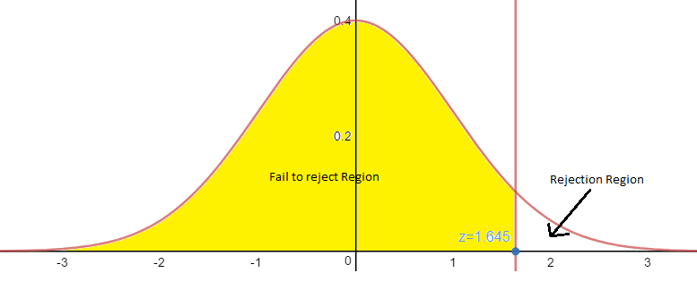
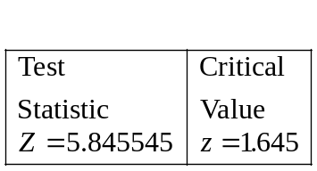
Example
Significance level 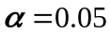

Examples “a” and “b” are both one tail look-ups on the z-score table
Example “c” is a two tail look-up on the z-score table

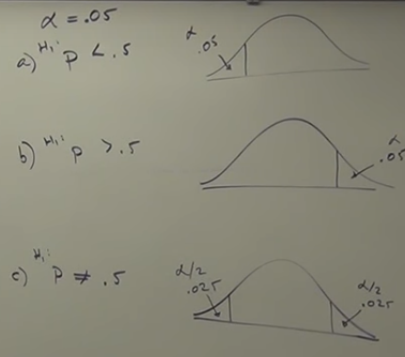

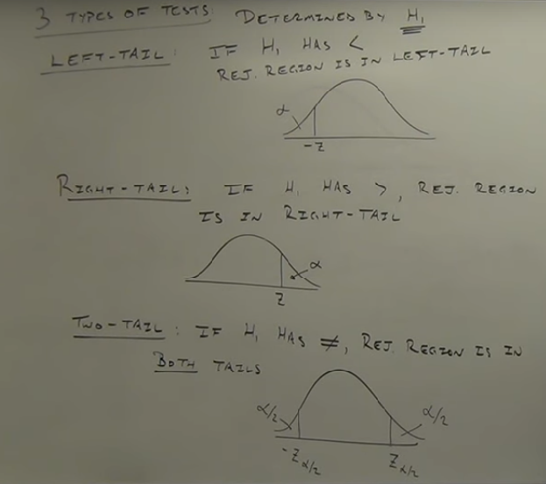

P-value: Probability associated with a test Statistic.
Only two decisions possible.
- Reject accept
- Fail to reject You know nothing about

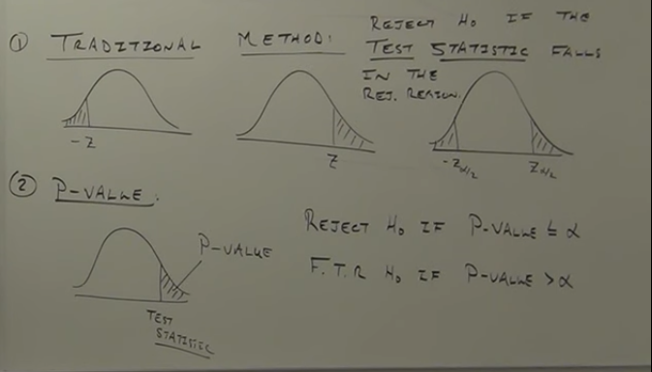

Find p-value:
You get a test Statistic of 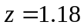

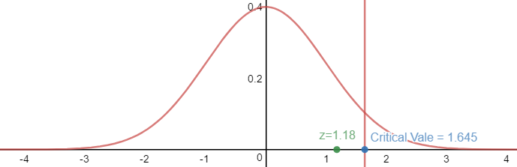
Traditional Method
Critical Value
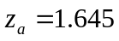

Fail to reject

P-value Method
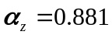
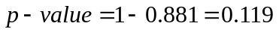
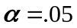
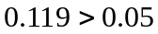 since P-value > we must fail to reject

